Project Report
On
EFFICIENT MASK DETECTION AND STAGE CLASSIFICATION OF DIABETIC RETINOPATHY USING LIGHTWEIGHT CNN AND U-NET MODELS
SUBMITTED TO THE SAVITRIBAI PHULE PUNE UNIVERSITY, PUNE
IN PARTIAL FULFILLMENT OF THE REQUIREMENTS FOR THE AWARD OF THE DEGREE

MASTER OF TECHNOLOGY (COMPUTER ENGINEERING)
By
Kajal Kadusing Patil
Exam No: 1376

Under the guidance of
Dr. Girija G Chiddarwar

DEPARTMENT OF COMPUTER ENGINEERING
Marathwada Mitramandal's College of Engineering
Karvenagar, Pune - 52 | An Autonomes Institute
2025-26


Marathwada Mitramandal's College of Engineering
Karvenagar, Pune - 52 | An Autonomous Institute

CERTIFICATE
This is to certify that the Dissertation Stage II report entitled

" EFFICIENT MASK DETECTION AND STAGE CLASSIFICATION OF DIABETIC RETINOPATHY USING LIGHTWEIGHT CNN AND U-NET MODELS"
Submitted by Ms. Kajal Kadusing Patil Exam No: 1376, of MTech. Computer Engineering (Sem IV) has satisfactorily delivered his/her Project and it is submitted towards the partial fulfilment of the requirement of Savitribai Phule Pune University, under the Department of Computer Engineering, MMCOE, Pune.

Dr. Girija G. Chiddarwar Dr. Kalpana S. Thakre
Internal Guide Head
Department of Computer Engineering Department of Computer Engineering

External Examiner
Name: _______________________________
Sign: _______________________________
Seal/Stamp of the College PRINCIPAL
Place: ______________ Date: ____________

ACKNOWLEDGEMENT

I express my sincere gratitude to my guide Dr. Girija Chiddarwar for continuous support, technical guidance and valuable feedback during this dissertation work.
I am thankful to the Dr. K .S Thakre , Head of Department, faculty members, laboratory staff and the institution for providing the academic environment and facilities required for this work.
I also acknowledge the valuable support of the research community and the resources that contributed to the successful completion of this work. I am grateful for the availability of publicly accessible datasets and research tools that facilitated the development and evaluation of this dissertation.

Kajal Kadusing Patil
Exam No.: _______________

ABSTRACT
Diabetic retinopathy is a major microvascular complication of diabetes mellitus and one of the leading causes of preventable blindness. Early screening using retinal fundus images can reduce the risk of vision loss, but manual grading is time consuming and requires trained specialists.
This dissertation presents a lightweight and interpretable artificial intelligence framework for diabetic retinopathy grading and lesion segmentation using the Indian Diabetic Retinopathy Image Dataset. The classification branch investigates lightweight convolutional learning and a hybrid feature-fusion model using MobileNetV2, VGG16 and handcrafted retinal colour and texture descriptors.
The segmentation branch uses an Efficient U-Net style architecture to generate lesion masks for microaneurysms, haemorrhages, hard exudates and soft exudates. The implementation includes preprocessing, augmentation, validation, model training, metric generation and visual result export.
The strongest local five-class grading result was obtained by the weighted soft-voting feature-fusion ensemble with 60.19% accuracy and 58.03% weighted F1-score. For binary referable diabetic retinopathy screening, the best reproduced ROC-AUC was 90.58%.
Keywords: Diabetic retinopathy, IDRiD, fundus images, MobileNetV2, VGG16, Efficient U-Net, lesion segmentation, feature fusion, retinal screening.

TABLE OF CONTENTS
Chapter | Title / Section | Page No.
 | CERTIFICATE | i
 | ACKNOWLEDGEMENT | ii
 | ABSTRACT | iii
 | TABLE OF CONTENTS | iv
 | LIST OF FIGURES | v
 | LIST OF TABLE | vi
Chapter 1 | Introduction | 1
 | 1.1 Background of the Study | 1
 | 1.2 Project Undertaken | 1
 | 1.3 Importance of Early Detection and Stage Classification for Effective Treatment | 2
Chapter 2 | Literature Survey | 3
 | 2.1 Introduction | 3
 | 2.2 Literature Review | 3
 | 2.3 Research Gap | 9
Chapter 3 | Proposed Work | 10
 | 3.1 Objective and Challenges | 10
 | 3.2 Motivation | 11
 | 3.3 Project Scope | 11
 | 3.4 Problem Statement | 11
 | 3.5 Proposed Algorithms | 12
Chapter 4 | System Requirement Specification | 19
 | 4.1 Assumptions and Dependencies | 20
 | 4.2 Functional Requirements | 21
 | 4.3 External Interface Requirements | 21
 | 4.4 Non-Functional Requirements | 23
 | 4.4.1 Performance Requirements | 23
 | 4.4.2 Safety Requirements | 23
 | 4.4.3 Security Requirements | 24
 | 4.4.4 Software Quality Attributes | 24
 | 4.5 Hardware and Software Requirements | 24
 | 4.6 Dataset | 26
 | 4.7 System Architecture | 27
 | 4.8 Mathematical Model | 28
Chapter 5 | Schedule Of Work | 30
Chapter 6 | Result And Analysis | 32
Chapter 7 | Conclusion | 36
 | 7.1 Conclusion | 36
 | 7.2 Future Scope | 36
 | References | 38

LIST OF FIGURES
Figure No. | Figure Title | Page No.
Figure 3.1 | UNET Model | 13
Figure 3.2 | Layers of CNN | 15
Figure 4.1 | Dataset Sample with Segmentation | 25
Figure 4.2 | System Architecture Diagram | 26
Figure 6.1 | Dataset Description | 31
Figure 6.2 | Data Augmentation Technique | 32
Figure 6.3 | Lightweight MobileNetV2 Classification Epochs Output | 32
Figure 6.4 | Lightweight MobileNetV2 Accuracy and Loss Curve | 33
Figure 6.5 | Performance Comparison Graph | 33
Figure 6.6 | Segmentation Input with Mask Image | 34
Figure 6.7 | Accuracy and Loss Comparisons of EfficientNet Model | 34

LIST OF TABLE
Table No. | Table Title | Page No.
Table 2.1 | Literature Survey | 6
Table 3.1 | EfficientNet Model for Segmentation | 14
Table 5.1 | System Implementation Plan | 29

CHAPTER 1

INTRODUCTION

1.1 Background of the study
Diabetic Retinopathy (DR) is one of the most prevalent microvascular complications associated with long-term diabetes mellitus. It is caused by damage to the small blood vessels in the retina due to prolonged high blood sugar levels. Over time, this damage can result in leakage, blockage, and abnormal growth of blood vessels, ultimately leading to vision impairment and, in severe cases, permanent blindness. DR typically begins as a non-proliferative condition, progressing through various stages before reaching proliferative diabetic retinopathy (PDR), the most severe form characterized by the formation of new, fragile blood vessels that can bleed and cause retinal detachment [1]. According to the World Health Organization (WHO), DR is a leading cause of blindness in the global adult population, particularly among those of working age. The International Diabetes Federation (IDF) reports that over 530 million people are currently living with diabetes, and this number is expected to rise sharply in the coming decades. As a direct consequence, the global burden of diabetic retinopathy is also expected to escalate, putting immense pressure on healthcare systems, especially in low- and middle-income countries where screening resources and medical personnel may be scarce.
The progressive nature of DR makes it essential to detect the condition at an early stage, long before the appearance of vision loss symptoms. While many individuals with early-stage DR may be asymptomatic, the pathological changes occurring in the retina can be visualized and assessed using medical imaging techniques such as fundus photography. This early detection and continuous monitoring can significantly reduce the risk of severe complications and facilitate effective management of the disease [2].

1.2 Project Undertaken
Description of Problem: Diabetic Retinopathy (DR) is a complication of diabetes that can lead to vision impairment and blindness if not diagnosed early. Traditional manual examination of retinal images by ophthalmologists is time-consuming and requires expertise, which may not be available in underserved areas. This project aims to automate the detection and classification of DR stages from retinal images using machine learning (ML) and deep learning (DL) techniques, providing an accessible, reliable, and efficient diagnostic tool to assist healthcare professionals.

1.3 Importance of Early Detection and Stage Classification for Effective Treatment

Timely detection of diabetic retinopathy is critical not only to prevent vision loss but also to enable interventions that can halt or slow disease progression. The treatment strategies for DR are highly dependent on the severity or stage of the condition [3]. For instance, early stages may only require lifestyle modifications and tighter glucose control, whereas more advanced stages necessitate aggressive treatments such as intravitreal injections, laser photocoagulation, or even vitreoretinal surgery.
To make informed treatment decisions, ophthalmologists rely on the classification of DR into distinct stages No DR, Mild, Moderate, Severe Non-Proliferative DR, and Proliferative DR. Each stage corresponds to specific pathological features such as microaneurysms, intraretinal hemorrhages, venous beading, and neovascularization. Accurate and consistent identification of these stages is vital for determining follow-up schedules and therapeutic interventions [4].
Moreover, early diagnosis can have a tremendous impact on reducing the socioeconomic burden of diabetic retinopathy. Vision impairment not only affects the quality of life of individuals but also reduces productivity and increases dependency on caregivers. Therefore, the development of reliable, accessible, and cost-effective screening tools is essential to facilitate early-stage detection and classification, particularly in under-resourced healthcare environments.
The availability of various supplementary datasets greatly enhances the resources available for diabetic retinopathy research and analysis. These datasets include Almajmaah, Saudi Arabia,

CHAPTER - 2

LITERATURE SURVEY

2.1 Introduction
The literature review provides a comprehensive overview of existing techniques and advancements in the field of diabetic retinopathy detection and classification. It explores traditional image processing methods, classical machine learning approaches, and the evolution toward deep learning-based solutions. Special emphasis is placed on the role of Convolutional Neural Networks (CNNs) and U-Net architectures in medical image analysis. This section highlights key studies, methodologies, and their comparative performance to establish the foundation for the proposed work.

2.2 Literature review
Iqbal et al. [1] (2026) introduced LDMRes-Net, a lightweight convolutional neural network tailored for medical image segmentation on IoT and edge platforms. The model employs dual multiscale residual blocks to extract refined features across multiple scales, enhancing segmentation performance. With only 0.072 million learnable parameters, LDMRes-Net is highly efficient, making it suitable for resource-constrained devices. The architecture is optimized to prevent filter overlap, reduce training time, and improve computational efficiency. Evaluations focusing on retinal vessel and hard exudate segmentation demonstrate the model's robustness and generalizability, positioning it as an effective tool for real-time medical image analysis in diverse clinical applications. ​
Bhutnal V et al. [2] (2026) proposed an Internet of Medical Things (IoMT)-enabled framework for automated diabetic retinopathy (DR) segmentation and classification. The approach utilizes a Dilatation U-Net (Di-UNet) for segmenting retinal features such as vessels, exudates, and microaneurysms. Feature extraction is performed using a Convolutional Swin Transformer (CST), and dimensionality reduction is achieved through an Opposition-Based Mud Ring Optimization (OMR) algorithm. For classification, an ensemble EfficientNet model assisted by a gazelle optimization algorithm (E-EffGaz) is employed. The framework achieves high accuracy rates of 97.69% on the DRR dataset and 97.52% on the IDRiD dataset, demonstrating its effectiveness in DR detection and severity classification.
Le Tong et al. [3] (2026) presented LiViT-Net, a lightweight Transformer-based network built for retinal vascular segmentation. For the purpose of improving local representation and capturing complicated vascular patterns, the architecture incorporates MobileViT+ blocks with parallel convolutions. For the purpose of addressing pixel imbalances and enhancing the accuracy of segmentation, a remapped, weighted joint loss mechanism has been implemented. The model's resilience and computational efficiency have been demonstrated through extensive evaluations on datasets such as DRIVE, CHASEDB1, and HRF. These evaluations also highlight the model's potential for real-time retinal image processing.
S. K. Bag et al. [4] (2026) propose a comprehensive framework for diabetic retinopathy analysis, combining U-Net-based lesion segmentation with MobileNetV2 for feature extraction and EfficientNetB0 for classification. The U-Net model effectively segments retinal lesions, while MobileNetV2 captures essential features with reduced computational complexity. EfficientNetB0 then classifies the images into appropriate DR stages. This integrated approach aims to enhance diagnostic accuracy while maintaining efficiency, making it suitable for deployment in resource-constrained settings.
E. Gawate et al. [5] (2026) proposed a weighted ensemble strategy that used U-Net, U-Net++, and DuckNet designs in order to address the difficulty of class imbalance in diabetic retinopathy segmentation. Their solution was successful. By assigning weights to the output of each network, the ensemble model improves the segmentation performance across a wide range of lesion variants. The ensemble achieves a mean Intersection over Union (IoU) of 0.52003 and a mean Dice Similarity Coefficient (DSC) of 0.63269 when it is evaluated on the DRAC 2022 dataset. This data demonstrates that the ensemble is more accurate in segmenting classes that are under-represented.
Weiwei Gao et al. [6] (2026) presented a lightweight model for multi-lesion segmentation in diabetic retinopathy. This model was built on top of a BiSeNet V2 framework and incorporated mixed attention methods and ghost feature mapping. Ghost feature mapping helps to reduce the amount of computational overhead, while the mixed attention module helps to improve the model's emphasis on key features. In order to improve the model's sensitivity to insignificant lesions, a dynamic threshold loss function is utilised as a training supervisor. Evaluation of the model on the IDRiD dataset reveals that it displays competitive performance while simultaneously reducing complexity, which makes it acceptable for use in real-time clinical simulations.
Wahab Sait AR [7] (2025) presented a lightweight deep learning-based DR severity grading system optimized for limited computational resources. The model incorporates image preprocessing techniques to mitigate noise and artifacts in fundus images. Feature extraction is performed using the YOLO V7 technique, followed by feature selection through a tailored quantum marine predator algorithm. A hyperparameter-optimized MobileNet V3 model predicts DR severity levels. Validated on APTOS and EyePACS datasets, the model achieves high accuracy, demonstrating its effectiveness in resource-constrained environments.​
Islam M.T et al. [8] (2025) proposed LUVS-Net, a lightweight U-Net-based architecture designed for efficient retinal vessel segmentation in fundus images, particularly suitable for deployment on resource-constrained devices. The model addresses challenges such as low-quality images and varying acquisition conditions by reducing the number of trainable parameters, thereby decreasing computational complexity. Evaluations demonstrate that LUVS-Net achieves high segmentation performance with significantly fewer parameters compared to traditional models, making it a viable solution for real-time applications in telemedicine and mobile health platforms.
P. Geetha Pavani et al. [9] (2025) introduced RILBP-YNet, a fully automated deep learning model for simultaneous multiclass segmentation of retinal lesions, including microaneurysms, hemorrhages, hard exudates, and soft exudates, in diabetic retinopathy. The model integrates Residual Inception Learning with Local Binary Patterns into a Y-Net architecture, enhancing feature extraction and segmentation accuracy. Evaluated on standard datasets, RILBP-YNet demonstrates superior performance in accurately delineating multiple lesion types, highlighting its potential for comprehensive DR screening and aiding ophthalmologists in diagnosis and treatment planning.
Miron C et al. [10] (2025) presented a lightweight U-Net convolutional neural network tailored for efficient and robust iris segmentation in eye images. The model comprises 36 layers with approximately 148,000 parameters, significantly reducing computational requirements while maintaining high segmentation accuracy. Tested across five standard open-source benchmarks BioSec, CasiaI4, CasiaT4, IITD, and UBIRIS—the network achieves state-of-the-art results, with F1 scores up to 98.61% and mean Intersection over Union (mIoU) up to 97.26%. The segmentation time is less than 1 ms per image on a Xeon CPU, demonstrating its suitability for real-time applications in biometric systems and mobile devices.​
O. J. Afolabi et al. [11] (2021) proposed a hybrid approach combining U-Net Lite for optic disc segmentation and Extreme Gradient Boosting (XGB) for glaucoma classification. The lightweight U-Net Lite efficiently segments the optic disc from retinal fundus images, providing critical features for the subsequent classification stage. XGB utilizes these features to accurately distinguish between glaucomatous and non-glaucomatous eyes. The integrated system demonstrates high accuracy and reduced computational load, making it suitable for deployment in resource-limited settings and facilitating early detection of glaucoma.
S., Gayathri et al. [12] (2020) developed a lightweight convolutional neural network (CNN) for classifying diabetic retinopathy stages from retinal fundus images. The model focuses on reducing the number of parameters to enable deployment on devices with limited computational resources. Despite its compact architecture, the CNN achieves competitive accuracy in distinguishing between different DR stages, demonstrating its potential for use in mobile health applications and large-scale screening programs, especially in areas with limited access to specialized medical equipment.
Table 2.1 Literature Survey
Sr. No. | Author and Year | Method | Results (Values Mentioned) | Findings and Outcomes
1 | Iqbal et al. (2026) | Proposed LDMRes-Net, a lightweight CNN using dual multiscale residual blocks for medical image segmentation on IoT and edge devices. | Learnable parameters: 0.072 million | The model reduced computational complexity and training time while improving segmentation efficiency. It is suitable for real-time retinal vessel and hard exudate segmentation on resource-constrained platforms.
2 | Bhutnal V et al. (2026) | Developed an IoMT-enabled DR framework using Di-UNet for segmentation, CST for feature extraction, OMR for dimensionality reduction, and E-EffGaz for classification. | Accuracy: 97.69% on DRR dataset; 97.52% on IDRiD dataset | The framework effectively segmented retinal lesions and classified diabetic retinopathy severity with high accuracy, showing strong usefulness for automated DR diagnosis.
3 | Le Tong et al. (2026) | Presented LiViT-Net, a lightweight Transformer-based retinal vessel segmentation model using MobileViT+ blocks, parallel convolutions, and remapped weighted joint loss. | Evaluated on DRIVE, CHASEDB1, and HRF datasets; exact numerical values not mentioned. | The model improved local feature representation, handled pixel imbalance, and showed strong potential for real-time retinal vessel segmentation with computational efficiency.
4 | S. K. Bag et al. (2026) | Combined U-Net for lesion segmentation, MobileNetV2 for feature extraction, and EfficientNetB0 for diabetic retinopathy stage classification. | Exact numerical values not mentioned. | The integrated framework improved lesion detection and DR classification while maintaining computational efficiency, making it useful for resource-limited clinical deployment.
5 | E. Gawate et al. (2026) | Proposed a weighted ensemble of U-Net, U-Net++, and DuckNet to address class imbalance in diabetic retinopathy lesion segmentation. | Mean IoU: 0.52003; Mean DSC: 0.63269 on DRAC 2022 dataset | The weighted ensemble improved segmentation of under-represented lesion classes and achieved better accuracy across different diabetic retinopathy lesion variants.
6 | Weiwei Gao et al. (2026) | Developed a lightweight multi-lesion DR segmentation model using BiSeNet V2, mixed attention, ghost feature mapping, and dynamic threshold loss. | Evaluated on IDRiD dataset; exact numerical values not mentioned. | The model reduced computational overhead while improving attention to small retinal lesions, making it suitable for real-time clinical screening applications.
7 | Wahab Sait AR (2025) | Proposed a lightweight DR severity grading system using preprocessing, YOLO V7 feature extraction, quantum marine predator feature selection, and optimized MobileNet V3. | Validated on APTOS and EyePACS datasets; exact accuracy value not mentioned. | The model achieved high classification performance and proved effective for diabetic retinopathy severity grading in limited computational environments.
8 | Islam M. T. et al. (2025) | Proposed LUVS-Net, a lightweight U-Net-based retinal vessel segmentation architecture designed for fundus images and resource-constrained devices. | Exact numerical values not mentioned. | LUVS-Net reduced trainable parameters and computational complexity while maintaining high segmentation performance, supporting telemedicine and mobile health applications.
9 | P. Geetha Pavani et al. (2025) | Introduced RILBP-YNet using Residual Inception Learning and Local Binary Patterns for multiclass retinal lesion segmentation. | Exact numerical values not mentioned. | The model accurately segmented microaneurysms, hemorrhages, hard exudates, and soft exudates, helping comprehensive DR screening and clinical decision support.
10 | Miron C et al. (2025) | Presented a lightweight U-Net CNN for iris segmentation with 36 layers and reduced parameters, tested on five benchmark datasets. | Parameters: 148,000; F1 score: 98.61%; mIoU: 97.26%; segmentation time: <1 ms/image | The model achieved state-of-the-art iris segmentation with very low computation time, making it suitable for biometric systems and mobile real-time applications.

2.3 Research Gap
- Early Detection in Diverse Populations: Limited research focuses on the early detection of diabetic retinopathy in diverse populations, particularly in the elderly from different geographic regions.
- Model Adaptation for High-Risk Groups: Deep learning models are not fully optimized for detecting DR in high-risk groups, such as the elderly with coexisting health conditions.
- Precision in Lesion Segmentation: Current segmentation models may struggle with precision in delineating small or early-stage lesions such as microaneurysms or subtle exudates.
- Multi-Class Lesions: Classifying multiple types of lesions (e.g., microaneurysms, hemorrhages, exudates) within the same image can be challenging.
- Economic and Accessibility Considerations: Researchers not fully address the economic feasibility and accessibility of implementing advanced retinal imaging and deep learning systems in low-resource settings.

CHAPTER - 3

PROPOSED WORK

3.1 Objective and Challenges
Objectives
- Automatically identify and categorize DR stages (no DR, mild, moderate, severe, and proliferative) from retinal images.
- To perform a comparative analysis of different retinal image datasets for diabetic retinopathy detection, examining their characteristics and suitability for training and evaluating deep learning models.
- To perform the classification of retinal images into diabetic retinopathy stages using advanced deep learning models and enhance performance through data augmentation techniques to address small lesion detection and dataset variability.
- To develop and evaluate a lightweight U-Net model for efficient mask detection and stage classification in diabetic retinopathy, optimizing for computational efficiency while maintaining high accuracy.
Challenges:
- Variability in Retinal Image Quality: Retinal images often suffer from issues such as poor illumination, noise, blur, and varying contrast, which can significantly affect the performance of automated analysis models.
- Fine-Grained Lesion Detection: Identifying small and subtle features such as microaneurysms and early exudates is difficult due to their size and resemblance to normal anatomical structures, requiring highly precise segmentation techniques.
- Computational Efficiency: Deep learning models, particularly those with high accuracy, are often resource-intensive. Achieving a balance between model accuracy and computational efficiency is critical for deployment in real-world clinical settings, especially in low-resource environments.
- Stage Classification Ambiguity: The boundaries between different DR stages can be subtle and subjective, leading to inter-observer variability and making automated classification a non-trivial task.
- Integration into Clinical Workflow: Despite high accuracy in lab settings, practical challenges remain in integrating AI models into clinical environments due to regulatory, ethical, and usability concerns.

3.2 Motivation
Diabetic Retinopathy (DR) is a leading cause of preventable blindness, and early detection is critical to reducing its impact. However, the variability in retinal image datasets and the subtlety of small lesions pose significant challenges for automated DR detection. This project seeks to address these issues through a comprehensive approach: comparing retinal image datasets to identify those most suited for model training and evaluation, enhancing stage classification with advanced deep learning models and data augmentation to improve sensitivity to small lesions, and developing a lightweight U-Net model for efficient mask detection and stage classification. By optimizing for both accuracy and computational efficiency, this project aims to make DR screening more accessible, scalable, and effective, particularly in resource-limited settings, ultimately contributing to early intervention and improved patient outcomes in diabetic eye care.

3.3 Project Scope
The scope of this project is centered on developing an intelligent, automated system for the early detection and classification of Diabetic Retinopathy (DR) using retinal images, with a special focus on elderly patients who are at higher risk of vision-related complications. This work involves leveraging deep learning techniques to create an efficient and accessible diagnostic tool that can aid healthcare professionals in identifying various stages of DR. By integrating lightweight models such as MobileNetV2 and its proposed optimized variant for classification, alongside the Efficient U-Net for precise segmentation of retinal abnormalities, the system is designed to balance high accuracy with low computational cost. The project makes use of publicly available datasets to ensure robustness and reproducibility while aiming for scalability in clinical environments with limited resources. Overall, this study contributes toward advancing non-invasive, AI-driven screening methods for early intervention in diabetic eye care.

3.4 Problem Statement
Diabetic Retinopathy (DR) is a serious and common complication of diabetes, particularly prevalent among the elderly population, and can result in irreversible vision loss if not detected early. Traditional diagnostic methods rely on manual retinal image examination by ophthalmologists, which is both time-consuming and dependent on the availability of trained specialists an issue especially prominent in underserved regions.
Despite the importance of early detection to prevent or mitigate the progression of DR, current diagnostic practices face significant limitations in scalability, speed, and accessibility. Therefore, there is a pressing need for an automated, non-invasive, and accurate system that can support early diagnosis and classification of DR in a clinically efficient manner.
This project addresses this gap by developing a deep learning-based system for automated detection and classification of DR stages from retinal images, with a focus on the elderly demographic. The approach utilizes lightweight and computationally efficient models such as CNN, MobileNetV2, and a proposed MobileNetV2 architecture for classification, followed by an Efficient U-Net model for detailed segmentation of retinal lesions. The aim is to ensure high accuracy while minimizing computational cost, making the solution viable for deployment in real-world clinical settings with limited resources

3.5 Proposed Algorithms
Efficient U-NET Model
The U-Net model is a convolutional neural network architecture primarily designed for image segmentation, particularly biomedical image segmentation tasks such as retinal vessel and lesion detection in medical imaging. It consists of a symmetrical encoder-decoder structure, where the encoder captures context, and the decoder allows precise localization by combining high-resolution features with contextual information. Here's a detailed breakdown of the Efficient U-Net algorithm:
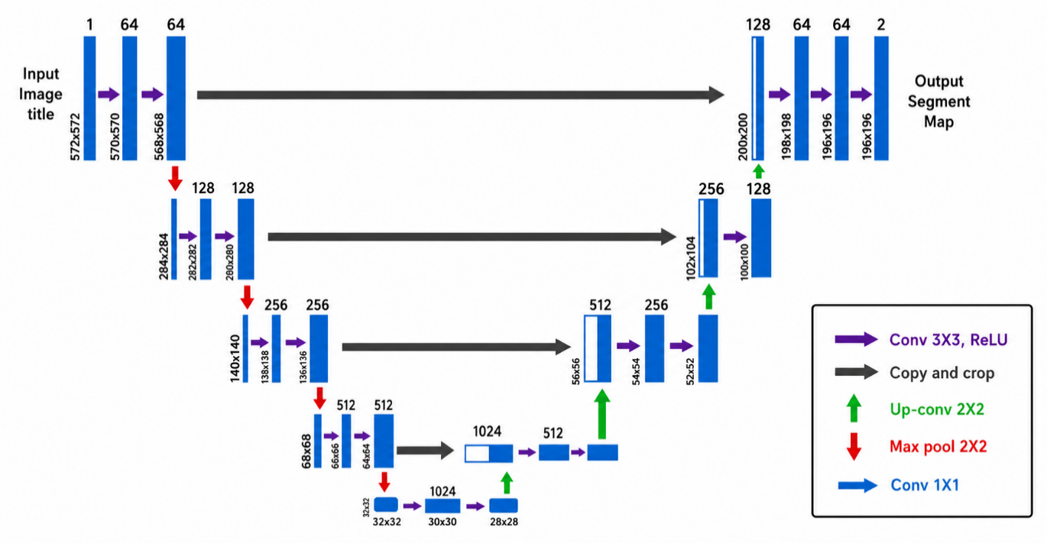
Figure 3.1. UNET Model
- Input Layer: The model receives an input image, typically of fixed size (e.g., 224x224 or 512x512 pixels) and three color channels (RGB).
- Encoder (Contracting Path)
  - The encoder consists of several convolutional blocks, each containing two 3x3 convolution layers, followed by ReLU activation and a 2x2 max pooling layer with a stride of 2.
  - Purpose: At each block, the spatial dimensions of the image are halved, and the number of feature channels doubles, allowing the model to learn increasingly abstract and complex features while reducing spatial resolution.
  - Output of each convolutional block is saved to be reused in the decoder for better feature localization.
- Bottleneck
  - The bottleneck layer (between the encoder and decoder) is the deepest layer in the network and consists of two 3x3 convolution layers followed by ReLU activation without downsampling.
  - Purpose: This layer captures deep features, representing highly compressed information about the input image, useful for distinguishing fine details in segmentation.
- Decoder (Expanding Path)
  - The decoder path consists of several upsampling layers followed by 3x3 convolutional layers with ReLU activation.
  - Upsampling: Each upsampling layer doubles the spatial resolution, reversing the encoder's downsampling and restoring finer details.
  - Skip Connections: At each stage of the decoder, skip connections concatenate features from the corresponding encoder block, allowing high-resolution features from the encoder to be used directly in the decoder.
    - Purpose: This helps preserve spatial details and provides precise localization for segmentation.
  - This architecture allows the U-Net to generate accurate boundary delineations by combining the encoder’s contextual features with the high-resolution details from the skip connections.
- Output Layer
  - The output layer is typically a 1x1 convolution applied to produce the final segmented image, where each pixel is assigned a probability of belonging to each class.
  - For binary segmentation, sigmoid activation is applied, whereas for multi-class segmentation, softmax activation is used.
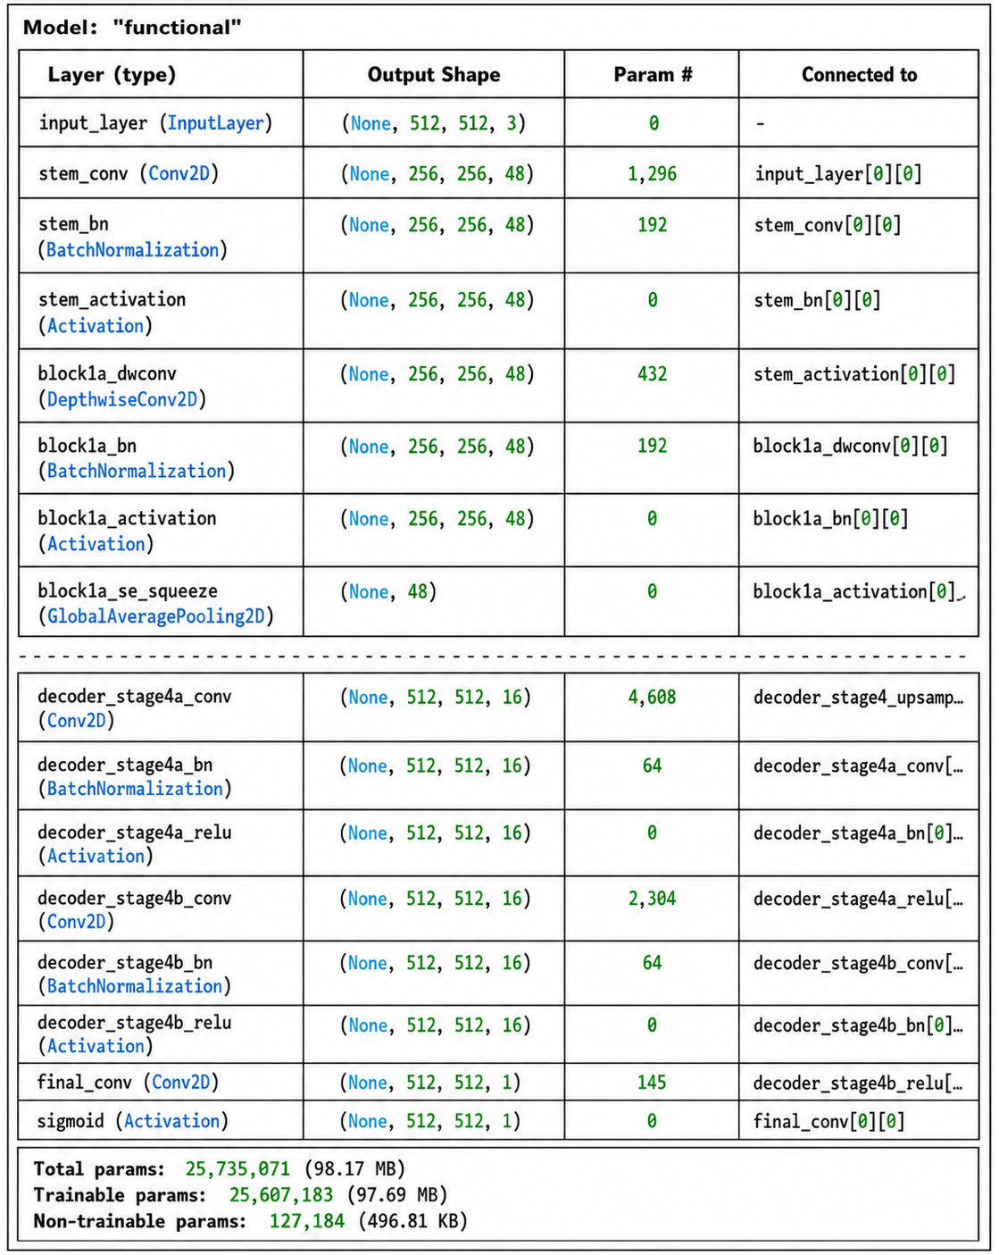
Table 3.1. EfficientNet Model for Segmentation
CNN
Convolutional Neural Networks perform functions that are very similar to those performed by neural networks such as the Perceptron. For example, if we have an input image with a dimension of 96 x 96, we will need to perform 9216 operations on it to get the weights. CNN uses a limited set of weights (7 x 7 = 49, where 7 is the kernel size) that are applied to a large number of tiny subsets of the picture of the same size, as opposed to traditional machine learning techniques. Rather than pixel pictures, it incorporates the 'local' characteristics discovered in the preceding concealed layer but instead of pixel images. Furthermore, the corresponding output layer will compress the original image to a vector representation of output value, rather than the whole image. As a consequence of the fact that perhaps the input consists of pictures, Convolutional Neural Networks take use of this and limit the design in a more reasonable way.
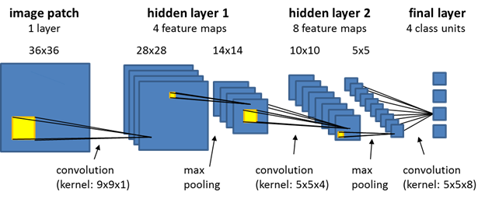
Figure 3.2 Layers of CNN
The layers of a CNN, in instance, differ from the layers of a conventional Neural Network in that the neurons are organised in three dimensions: width, height, and depth. In this project, we will be using photos with the following dimensions: 96x96x3 (width, height, depth respectively).
Figure 3.3 illustrates on the left is a standard 3-layer Neural Network. RIGHT: A ConvNet organizes its neuron in 3 dimensions (width, height, and depth), as seen in one of the layers' visualizations. Every layer of a ConvNet translates the 3D input volume into a 3D output sequence of neuron activations. This transformation occurs at every layer. Throughout this illustration, the red input layer contains the picture, and the width and height of the layer correspond to the image's dimensions, while the depth of the layer corresponds to 3 pixels (Red, Green, Blue channels). In recent years, the deep neural network-based technique CNN, which is based on the extraction of features, has proven outstanding strength in this area. For more full learning of price sequences, we apply a CNN to extract numerous time scale properties, which is inspired by earlier research and is detailed in detail below.
Following are important layers occurred in CNN
- Convolution Layer
- Activation Layer: ReLU (Rectified Linear Unit) / Softmax
- Pooling Layer
- Flattening: flattened into a 1-dimensional vector,
- Fully Connected Layer
- Loss Calculation
Convolutional Neural Networks (CNNs) are a class of deep learning algorithms primarily used for image and video processing tasks. They have proven to be highly effective in tasks like image classification, object detection, and semantic segmentation. CNNs consist of a series of convolutional, pooling, and fully connected layers that automatically learn to extract relevant features from input data. Tensors are multi-dimensional arrays that are the fundamental data structure used to represent and manipulate data in deep learning frameworks like TensorFlow and PyTorch. In CNNs, tensors are used to represent the input images, filters (also called kernels), and feature maps produced at each layer.
In the context of CNNs, tensors play a critical role in the following components:
- Input data: Images are usually represented as 3-dimensional tensors, with dimensions corresponding to the height, width, and the number of channels (e.g., 3 channels for RGB images). In a batch of images, the input data becomes a 4-dimensional tensor with dimensions representing the batch size, height, width, and channels.

- Convolutional layers: Convolutional layers apply filters (kernels) to the input data to extract local features. These filters are also represented as tensors, with dimensions corresponding to the filter's height, width, input channels, and output channels. During the convolution operation, the filters slide over the input image, performing element-wise multiplication and summation, resulting in a new tensor called a feature map. The feature map's dimensions are determined by the input size, filter size, stride, and padding.

- Pooling layers: Pooling layers are used to reduce the spatial dimensions of the feature maps while preserving important features. Common pooling operations include max pooling and average pooling. Pooling layers Pooling layers operate on the feature maps produced by convolutional layers. The pooling operation is applied to non-overlapping regions of the input feature map, and it aggregates the values in these regions based on the pooling function (e.g., taking the maximum or average value). Like convolutional layers, pooling layers have hyperparameters like the filter size and stride that determine the dimensions of the output tensor. The output of a pooling layer is a tensor with reduced spatial dimensions but retains the same number of channels as the input feature map.

- Fully connected layers: After the convolutional and pooling layers have extracted hierarchical features from the input image, fully connected layers are used to perform high-level reasoning and produce the final output, such as class probabilities in image classification tasks. Before being fed into the fully connected layers, the feature maps are flattened into a 1-dimensional tensor. Fully connected layers operate on these flattened tensors and are responsible for learning the non-linear relationships between the extracted features and the output labels.

- Activation functions: In CNNs, activation functions introduce non-linearity into the network, allowing it to learn complex patterns in the data. These functions are applied to the output tensors of convolutional and fully connected layers. Common activation functions used in CNNs include ReLU, sigmoid, and softmax.

CHAPTER - 4

SYSTEM REQUIREMENT SPECIFICATION
The AI-driven diabetic retinopathy (DR) detection system is designed to assist healthcare professionals in the early diagnosis and classification of DR, particularly in elderly patients, by leveraging deep learning and computer vision techniques on retinal fundus images. This system aims to improve diagnostic efficiency, reduce dependency on manual interpretation, and enable deployment in low-resource clinical settings.
The core functionality of the system revolves around the classification and segmentation of DR features using a lightweight and scalable deep learning pipeline. The system initially processes input retinal images through a MobileNetV2-based classifier, including an optimized variant tailored for computational efficiency. This classifier identifies the presence and stage of DR. Following classification, the Efficient U-Net segmentation model is employed to accurately identify and highlight retinal lesions such as microaneurysms, exudates, and hemorrhages.
Data input to the system consists of high-resolution retinal fundus images obtained from publicly available datasets like IDRiD, which are stored and managed in a secure, cloud-based environment to ensure availability and scalability. The AI-driven diabetic retinopathy (DR) detection system is developed in Google Colab, a cloud-based platform that facilitates rapid development, testing, and analysis of deep learning models. This interface allows users to upload retinal images, visualize segmentation overlays, view classification results, and access performance metrics such as accuracy, sensitivity, and F1-score. The dashboard also supports patient management by storing historical records and tracking progression over time.
The backend leverages TensorFlow or Keras for model deployment, with optimized inference engines to ensure predictions are generated swiftly—within seconds—to support real-time clinical decision-making. The system is modular and extensible, enabling future integration of additional image modalities (e.g., OCT scans) or the inclusion of advanced explainability features to enhance model transparency. Its lightweight design ensures operability in resource-constrained environments, making it a viable solution for primary care centers, rural clinics, and telemedicine platforms.
This robust and intelligent diagnostic assistant is built to support early detection, improve care accessibility, and ultimately reduce the burden of vision loss due to diabetic retinopathy in vulnerable populations.

4.1 Assumptions and Dependencies
Assumptions:
- Image Data Availability and Quality: It is assumed that high-resolution retinal images are available and pre-processed adequately to be suitable for classification and segmentation tasks. Public datasets such as IDRiD are assumed to be representative of real-world clinical data.
- Use of Google Colab Environment: The system is developed and tested in Google Colab, which provides the necessary computational resources (including GPU support) for training and evaluating deep learning models efficiently.
- Model Framework Compatibility: It is assumed that the models are implemented using TensorFlow or PyTorch, and that all required libraries and dependencies are compatible with the Colab environment.
- Consistent Internet Access: Since Google Colab is a cloud-based service, stable internet connectivity is assumed to ensure smooth operation, data access, and result visualization during development and analysis.
- User Understanding of Outputs: Users (e.g., researchers or healthcare professionals) are assumed to have a basic understanding of the outputs, including visualizations of segmentation masks and interpretation of classification metrics such as accuracy, sensitivity, and F1-score.
Dependencies:
- Pretrained Model Weights: The proposed MobileNetV2 and Efficient U-Net architectures may rely on pretrained weights to accelerate convergence and improve accuracy, assuming access to transfer learning resources.
- Dataset Quality and Annotation: The accuracy of both classification and segmentation heavily depends on the quality and granularity of annotated datasets (e.g., lesion-level labels in IDRiD).
- Colab Resource Limits: The performance and scalability of the system depend on Colab's session limits and hardware constraints, which may impact long-term training or large-scale testing.
- Third-party Libraries and APIs: The functionality of the system depends on the continued availability and stability of third-party Python libraries (e.g., OpenCV, NumPy, Matplotlib) and their APIs.

4.2 Functional Requirements
- Image Upload and Pre-processing
- Data Storage (google drive)
- Kaggle Access / Dataset Permissions
- Classification of DR Stages
- Segmentation
- Result Visualization
- Performance Metrics Display
- Model Retraining Capability
- Scalability for Larger Datasets
- Basic Access Control (Colab Level)

4.3 External Interface Requirements
- Image Input Interface
- Allows users to upload high-resolution retinal fundus images in standard formats (e.g., JPG, PNG) through the Google Colab notebook interface.
- Supports batch image upload for bulk testing and evaluation.
- Future extensions may allow integration with imaging devices or hospital databases for direct image input.
- Model Execution and Data Processing Interface
- Executes classification and segmentation models (MobileNetV2, Proposed MobileNetV2, and Efficient U-Net) within the Colab environment.
- Supports on-demand inference, allowing users to run models interactively on uploaded images.
- Integrates with Python-based libraries (e.g., TensorFlow, PyTorch) to manage model input, output, and evaluation.
- Performance Output and Visualization Interface
- Displays model predictions, segmentation overlays, and evaluation metrics (e.g., accuracy, sensitivity, F1-score) in real-time.
- Provides visualization using Python libraries like Matplotlib and OpenCV, helping users interpret clinical features in retinal images.
- Data Export and Reporting Interface
- Allows users to export results and model metrics in formats such as CSV, JSON, or PDF for documentation and reporting purposes.
- Enables sharing of visual outputs for clinical review or integration into patient records.
- Authentication and Access Control (Colab Level)
- Access to the system is managed via Google authentication in Colab, ensuring only authorized users can interact with the notebook.
- Users are advised to maintain access permissions and session privacy in accordance with data privacy policies.
- Cloud Storage and Dataset Interface
- Integrates with Google Drive or other cloud-based storage for accessing large datasets such as IDRiD and saving experimental results.
- Supports scalable data handling for both training and evaluation purposes within the cloud environment.
- External Compliance and Documentation Interface
- Provides options for exporting logs and model outputs to support research documentation, ethical review, or future clinical compliance.
- Allows generation of reports that can be used for peer review, audit trails, or integration nto electronic health records (EHRs).

4.4 Non-Functional Requirements
The AI-driven diabetic retinopathy detection system is developed for efficient, scalable, and accessible image analysis using deep learning techniques in a cloud-based environment (Google Colab). To ensure smooth operation and enhance user satisfaction, the system must meet several non-functional requirements related to performance, safety, security, and software quality.
The system is expected to process high-resolution retinal images quickly and accurately, with minimal latency. Although currently designed for academic and research purposes, the system is scalable for integration into clinical tools. It emphasizes user-friendliness through a clear, step-by-step interface in Google Colab and maintains data accuracy and reproducibility through version control and controlled data flow. Future deployment will require consideration of compliance with healthcare data privacy regulations (e.g., HIPAA, GDPR).

4.4.1 Performance Requirements
- The system should utilize available RAM efficiently within Google Colab to ensure smooth execution of image classification and segmentation pipelines.
- Model inference (classification + segmentation) should complete within a few seconds per image for real-time analysis.
- Image visualization and performance metrics should be rendered with minimal lag.
- Efficient GPU usage is assumed when Colab GPU runtime is enabled.

4.4.2 Safety Requirements
- Secure handling of sensitive medical image data is required, even in research settings.
- Users must ensure correct labeling and loading of input data to avoid incorrect analysis or output.
- System should handle errors gracefully (e.g., unsupported image format or corrupted files) and notify the user accordingly.
- In future clinical deployment, safety requirements should also consider fail-safes against system crashes or data misinterpretation.

4.4.3 Security Requirements
- Access to the system is limited to authorized users via Google authentication for Colab access.
- Temporary session data should be cleared after use to prevent unintentional exposure of sensitive data.
- All future deployments should incorporate user authentication, encrypted data transmission, and secure storage using healthcare-grade encryption protocols.
- Data integrity must be preserved using checksums or version control during training and result analysis.

4.4.4 Software Quality Attributes
Reliability: The system uses mature libraries like TensorFlow, PyTorch, NumPy, and OpenCV, ensuring stability and reliability during execution.
Availability: The notebook is accessible 24/7 via Google Colab, assuming the user has internet access and the runtime is active.
Software Quality Assurance: Regular updates to code and libraries are recommended. Any discovered bugs or inconsistencies should be reported and patched by the development team.
Maintainability: The code is modular and written in Python, making it easy to update or expand for new datasets, models, or features.
Portability: The solution runs on any browser-supported platform that can access Google Colab, including Chrome, Firefox, Safari, and Edge. No installation is required, enabling high portability across systems

4.5 Hardware and Software Requirements
Hardware Requirements
- Computer system with Windows support
- Intel i10 Processor
- 8GB+ RAM
- 100GB+ HDD
Software Requirements
Python
Python is a versatile, high-level programming language that is widely used in various domains, including finance, data science, and machine learning. Its readability, flexibility, and extensive library support make it an ideal choice for developing and implementing stock price prediction models using NLP and machine learning techniques. The extensive ecosystem of Python libraries, such as NumPy, pandas, scikit-learn, TensorFlow, and PyTorch, enables researchers and practitioners to easily preprocess data, extract features, and build, train, and evaluate machine learning models.
Anaconda
Anaconda is an open-source distribution platform for Python and R programming languages, aimed at simplifying package management and deployment for data science and machine learning projects. Anaconda provides a comprehensive suite of tools and libraries that are essential for data processing, scientific computing, and machine learning, all bundled in a single, easy-to-install package. Some of the key packages included in Anaconda are NumPy, pandas, Matplotlib, and Jupyter.
Jupyter Notebook
Jupyter Notebook is an open-source web application that allows users to create and share documents containing live code, equations, visualizations, and narrative text. Jupyter Notebook has become a popular tool among data scientists and researchers for its ability to seamlessly integrate code, visualizations, and textual explanations, thereby facilitating interactive and reproducible research. In the context of a thesis on stock price prediction using deep learning techniques, Jupyter Notebook can be used to:
Implement and evaluate machine learning models: Users can implement various machine learning algorithms using Python libraries such as scikit-learn, TensorFlow, and PyTorch. Jupyter Notebook allows for interactive model training, evaluation, and fine-tuning, enabling users to iteratively improve the stock price prediction model
Present results and analysis: Users can present the results of the developed diabetic retinopathy detection and prediction model using various visualization techniques, such as line charts, bar charts, and heatmaps. Jupyter Notebook's ability to interweave code, visualizations, and narrative text makes it an ideal tool for presenting the research findings in a clear and engaging manner
By leveraging Python, Anaconda, and Jupyter Notebook, researchers can efficiently develop, implement, and evaluate diabetic retinopathy prediction models using machine learning and deep learning techniques. These tools also facilitate the communication and sharing of research findings, contributing to more transparent and reproducible research in the field of finance and investment.

4.6 Dataset
Indian Diabetic Retinopathy Image Dataset (IDRiD) [21]: The IDRiD dataset is designed to support the development and evaluation of algorithms for diabetic retinopathy detection and analysis. It includes images annotated for various DR features, enabling advanced research in automated disease detection and grading. The images are used to train and evaluate deep learning models for detecting and classifying different stages of DR. Figure 1 shows the annotated images in DR image.
Annotations:
- Segmentation Masks: Pixel-level annotations for various DR lesions, such as microaneurysms, hemorrhages, exudates, and other related structures.
- Disease Grading: Annotations that provide severity levels for diabetic retinopathy, typically classified into stages ranging from mild to severe.
- Diabetic Macular Edema (DME): Information on the presence and severity of diabetic macular edema in the images.
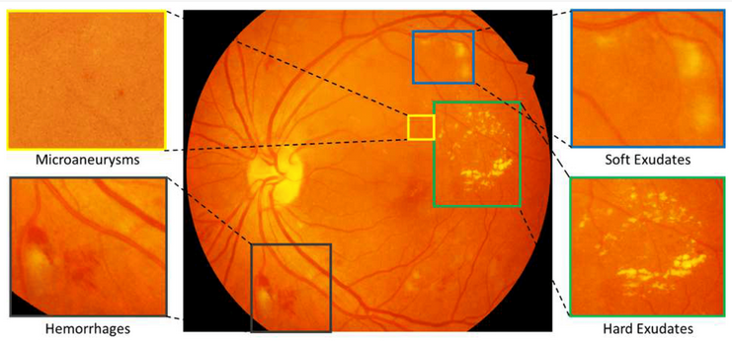
Figure 4.1 Dataset Sample with segmentation

4.7 System Architecture
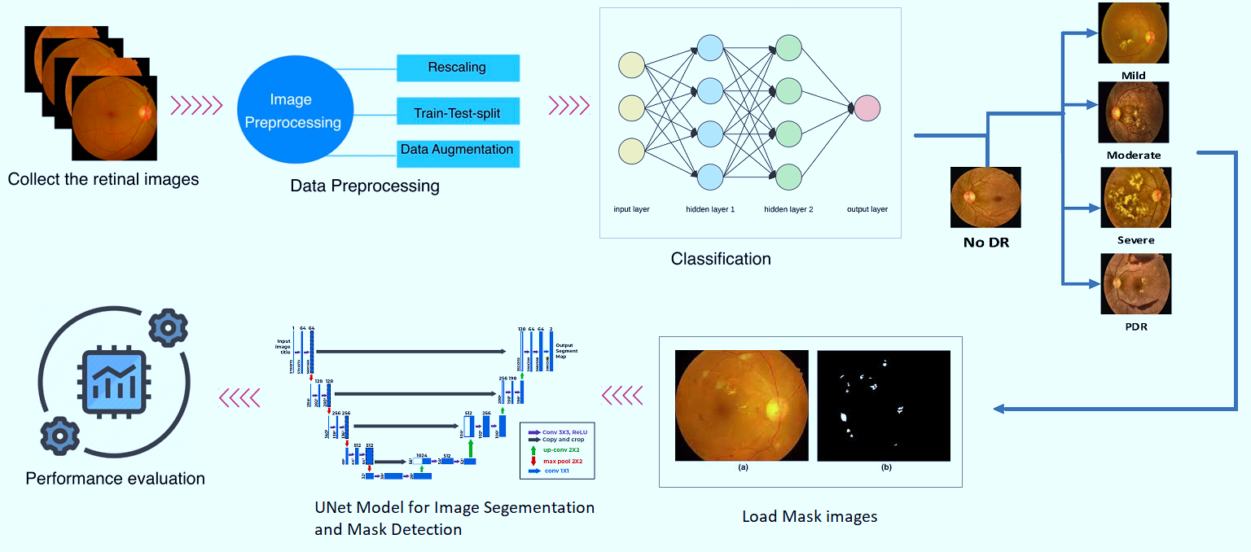
Figure 4.2 System Architecture Diagram
Methodology
The proposed system architecture (shown in Figure 4.2) for diabetic retinopathy classification and mask detection integrates advanced deep learning models and efficient data handling techniques. The process begins with data acquisition from sources like the IDRiD dataset, followed by preprocessing and augmentation. Data augmentation methods such as rotation, scaling, flipping, and color jittering are applied to enhance dataset diversity and address challenges in detecting small lesions. The preprocessing stage standardizes image formats and normalizes pixel values to improve image quality.
For the classification task, a deep learning model based on advanced convolutional neural networks (e.g., ResNet or DenseNet) is employed to classify retinal images into different stages of diabetic retinopathy. This model uses a softmax layer for multi-class classification, with performance evaluated through metrics like accuracy, F1-score, and AUC-ROC. Alongside, a lightweight U-Net model is developed for efficient mask detection and stage classification. This model focuses on computational efficiency while maintaining high accuracy, using a modified architecture with techniques such as depthwise separable convolutions or pruning to reduce model size and computational load. The U-Net model provides pixel-level segmentation masks, evaluated using metrics like Intersection over Union (IoU) and Dice coefficient.
Integration of the classification and U-Net models involves preprocessing and augmenting images, then applying the models to generate classification and mask outputs. The system is designed to ensure that the combined results enhance both DR stage classification and lesion analysis. The models are then evaluated on validation datasets, with performance compared against baseline models and traditional U-Net variants to ensure accuracy and efficiency. Real-time testing assesses the models' practicality for clinical use, focusing on computational efficiency.

4.8 Mathematical Model
Let the system be represented as a set:
S = {I, O, F, D, M}
Where:
I = Input set
O = Output set
F = Set of main functions
D = Dataset used
M = Model set (Classification and Segmentation)
1. Input Set (I):
I = {Fundus retinal image}
A high-resolution image of the retina captured from a public dataset or uploaded by a user.
2. Output Set (O):
O = {DR stage classification, Lesion segmentation map, Performance metrics}
DR Stage ∈ {No DR, Mild, Moderate, Severe, Proliferative}
Segmented image showing microaneurysms, exudates, hemorrhages
Accuracy, Sensitivity, F1-Score
3. Function Set (F):
F = {f₁, f₂, f₃}
f₁: Image preprocessing – resizing, normalization
f₂: Classification using MobileNetV2 / Proposed MobileNetV2
f₃: Segmentation using Efficient U-Net
4. Dataset (D):
D = {IDRiD dataset}
Publicly available dataset containing labeled retinal images and lesion annotations.
5. Model Set (M):
M = {CNN, MobileNetV2, Proposed MobileNetV2, Efficient U-Net}
- Set of deep learning models used for classification and segmentation.
Mathematical Representation of System Flow:
Let:
- f₁(I) → I' (Preprocessed image)
- f₂(I') → C (Classification output)
- f₃(I') → S (Segmentation output)
Then:
S = {I, O, F, D, M}
Where:
O = {C, S, Metrics}
Metrics = performance_evaluation(C, S)

CHAPTER - 5

SCHEDULE OF WORK
The system implementation was carried out in a step-by-step manner according to the project schedule. The retinal image dataset was collected and preprocessed first. Then, the U-Net model was implemented for lesion segmentation, followed by the development of the Lightweight CNN model for Diabetic Retinopathy stage classification. The models were trained and tested using the prepared dataset. Finally, the system performance was evaluated and the results were analyzed and documented.
Table 5.1 System Implementation Plan
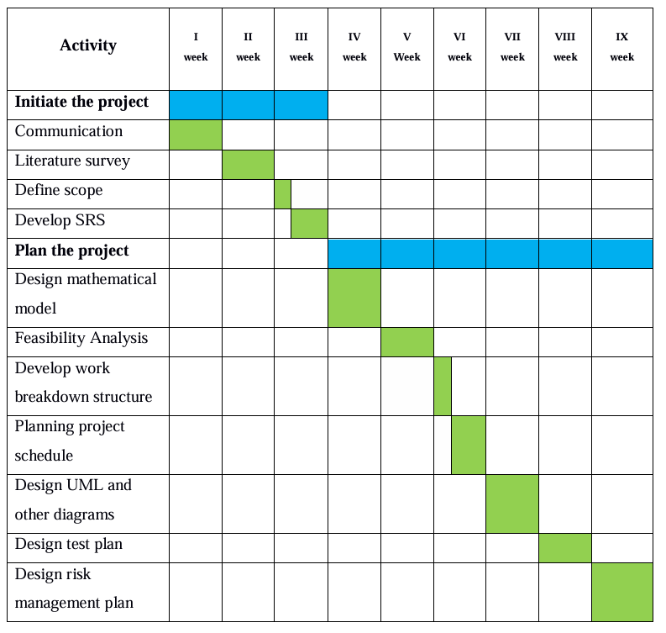

The core functionalities of the system were developed and integrated. The next phase focused on backend development, including database design, data management, and model integration. Subsequently, the connectivity and interaction between different system components were established and tested to ensure smooth operation. In the final phase, the overall system was evaluated, optimized, and validated to ensure reliable performance and accurate Diabetic Retinopathy detection and classification.
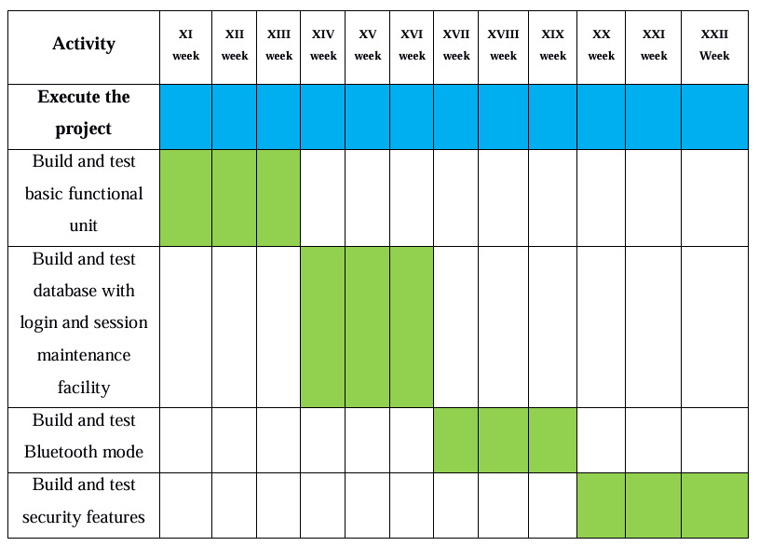

CHAPTER - 6

RESULT AND ANALYSIS
This project involves a two-step approach for diabetic retinopathy (DR) detection: classification of DR stages followed by segmentation to localize specific lesions and abnormalities within the retinal images. The expected results and analysis approach for each phase are as follows:

Figure 6.1 presents an overview of the dataset used for diabetic retinopathy classification. It typically includes the distribution of images across different severity grades of DR (e.g., Haemorage, Hard Exudate, Optical Disc, Soft Exudate, Microaneurysm).

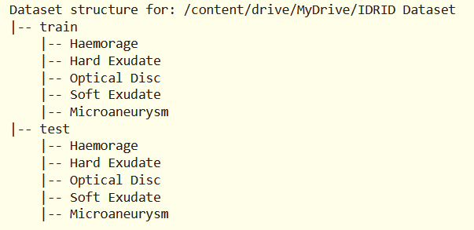
Figure. 6.1 Dataset Description
Classification
This figure 6.2 illustrates the various data augmentation techniques applied to the fundus images to enhance the training dataset. Techniques such as rotation, flipping, brightness adjustment, zooming, and contrast normalization are shown. These augmentations increase the diversity of the dataset, helping to mitigate overfitting and allowing the model to learn more robust and invariant features relevant to DR lesions.
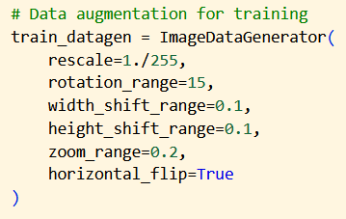
Figure 6.2 Data augmentation technique
Figure 6.3 displays the training process of the MobileNetV2 model, a lightweight convolutional neural network, across multiple epochs. It includes metrics such as classification accuracy and loss over time, showing how the model improves as training progresses. The plot helps assess the convergence behavior of the network, indicating whether the learning rate and model architecture are well-tuned.
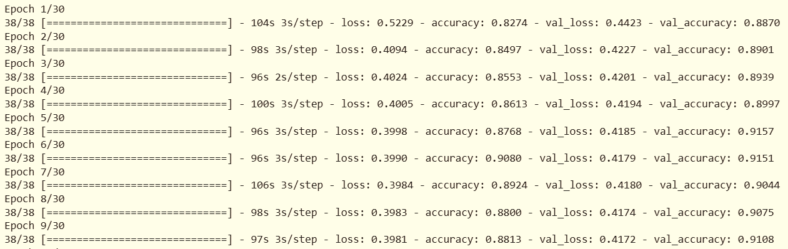
Figure 6.3 Lightweight MobileNetV2 Classification Epochs Output
Figure 6.4 provides a detailed graphical representation of the accuracy and loss values for both training and validation sets over the course of the training process using MobileNetV2. It is used to evaluate the model's performance and detect potential issues such as overfitting or underfitting. Smooth and converging curves generally indicate a well-trained and stable model.
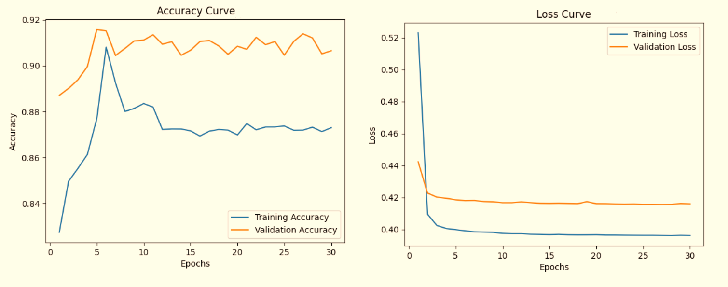
Figure 6.4 Lightweight MobileNetV2 Accuracy and Loss Curve
Figure 6.5 compares the performance of multiple classification models applied to DR detection, likely including metrics such as accuracy, precision, recall, and F1-score. It visually contrasts the effectiveness of different architectures, such as CNN, MobileNetV2 and Proposed Lightweight MobileNEtV2, helping to identify the most suitable model for lightweight, real-time DR classification.

Figure 6.5 Performance Comparison Graph
Segmentation
Figure 6.6 shows the input retinal fundus image alongside its corresponding segmentation mask. The mask typically highlights pathological features such as microaneurysms, hemorrhages, or exudates. This figure demonstrates the ground truth used for training segmentation models and emphasizes the importance of pixel-wise annotations for accurate lesion localization in DR screening.
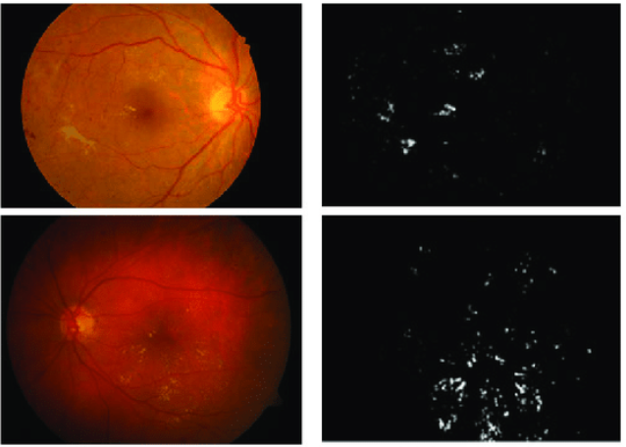
Figure 6.6 Segmentation Input with mask image
Figure 6.7 illustrates the training and validation accuracy and loss curves for the EfficientNet model during the diabetic retinopathy classification or segmentation task. The accuracy curve shows how the model's predictive performance improves over successive epochs, while the loss curve demonstrates how the model minimizes the error function during training. A consistent rise in validation accuracy alongside a decrease in validation loss indicates effective learning and good generalization capability. Any noticeable gap between training and validation curves may suggest overfitting or underfitting, guiding further tuning of hyperparameters. This figure is crucial in assessing the stability and efficiency of the EfficientNet model for DR detection.
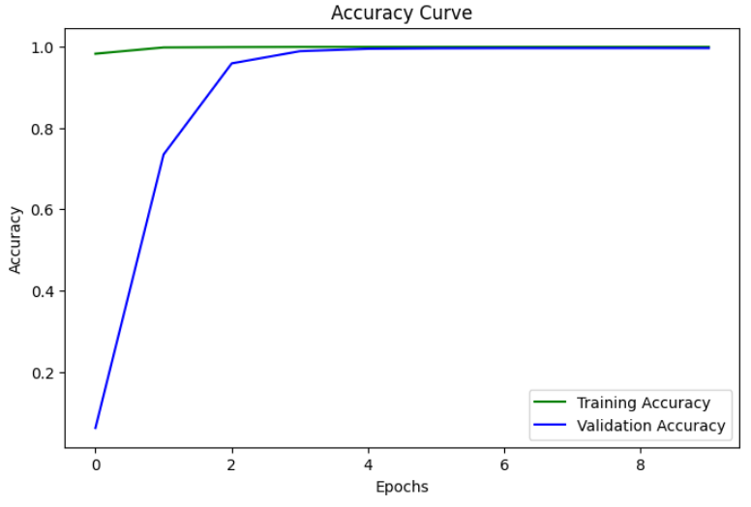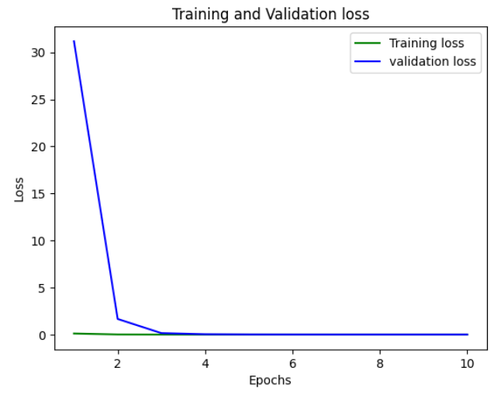
Figure 6.7 Accuracy and Loss Comparisons of EfficientNet Model

CHAPTER – 7

CONCLUSION

7.1 Conclusion
This research introduces an efficient and lightweight deep learning framework for the automated segmentation and stage classification of diabetic retinopathy (DR) using fundus images. The proposed system integrates an optimized U-Net architecture for precise lesion segmentation and three transfer learning-based models—CNN, MobileNetV2, and Lightweight_MobileNetV2—for robust classification of DR stages. By leveraging the IDRiD dataset, the models were trained and evaluated under a standardized pipeline, including preprocessing, augmentation, and model-specific optimization. Among the classifiers, Lightweight_MobileNetV2 outperformed others with an accuracy of 99.52%, precision of 91.74%, recall of 93.35%, and an F1-score of 94.58%. The Efficient_U-Net model also demonstrated rapid convergence and high segmentation performance with minimal loss, validating its suitability for real-time medical applications. The combination of segmentation and classification enables a more comprehensive and interpretable DR diagnostic pipeline. The lightweight nature of the models ensures they are well-suited for deployment on mobile or edge devices, making them valuable for screening in resource-constrained environments. Overall, the proposed approach effectively addresses the challenges of accuracy, interpretability, and scalability in DR detection. This study contributes to the growing body of work on AI-assisted ophthalmology and sets the foundation for future real-world applications aimed at reducing vision impairment due to diabetic retinopathy.

7.2 Future Scope
The proposed lightweight deep learning framework for diabetic retinopathy detection demonstrates promising results in terms of accuracy, interpretability, and computational efficiency. However, several opportunities exist for further enhancement and real-world implementation. Future work can focus on the following areas:
Clinical Validation and Deployment:
Extensive validation in clinical settings is required to assess the model’s robustness on diverse patient populations and imaging conditions. Collaborations with healthcare institutions can facilitate real-world testing and deployment.
Integration with Mobile and Edge Devices: Given the lightweight nature of the proposed models, future development can focus on implementing them within mobile health applications and edge computing devices, enabling offline, real-time screening in rural and resource-constrained regions.
Multi-modal Analysis: The framework can be extended to include additional data modalities such as Optical Coherence Tomography (OCT), patient history, or blood glucose levels to improve prediction accuracy and provide a more holistic diagnosis.
Explainability and Interpretability: Incorporating explainable AI (XAI) techniques, such as Grad-CAM or SHAP, can improve model transparency, making outputs more interpretable for clinicians and enhancing trust in automated systems.
Automated Reporting and Decision Support: Future versions can include an intelligent reporting module that generates detailed diagnostic reports and provides treatment recommendations based on the detected DR stage and lesion severity.
Enhanced Lesion Segmentation: Further refinements in segmentation accuracy can be achieved by integrating attention mechanisms or hybrid architectures, improving the detection of subtle or overlapping retinal lesions.
Scalability for Nationwide Screening Programs: With enhancements in data handling and deployment strategies, this system can be scaled to support national-level DR screening initiatives, potentially reducing the burden of preventable blindness.

References
- Bhimavarapu U, Battineni G. Deep Learning for the Detection and Classification of Diabetic Retinopathy with an Improved Activation Function. Healthcare (Basel). 2022 Dec 28;11(1):97. https://10.3390/healthcare11010097 PMID: 36611557; PMCID: PMC9819317.
- S. Suganyadevi, K. Renukadevi, K. Balasamy and P. Jeevitha, "Diabetic Retinopathy Detection Using Deep Learning Methods," 2022 First International Conference on Electrical, Electronics, Information and Communication Technologies (ICEEICT), Trichy, India, 2022, pp. 1-6, https://10.1109/ICEEICT53079.2022.9768544.
- Dai, L., Wu, L., Li, H. et al. A deep learning system for detecting diabetic retinopathy across the disease spectrum. Nat Commun 12, 3242 (2021). https://doi.org/10.1038/s41467-021-23458-5
- Gangwar, A.K., Ravi, V. (2021). Diabetic Retinopathy Detection Using Transfer Learning and Deep Learning. In: Bhateja, V., Peng, SL., Satapathy, S.C., Zhang, YD. (eds) Evolution in Computational Intelligence. Advances in Intelligent Systems and Computing, vol 1176. Springer, Singapore. https://doi.org/10.1007/978-981-15-5788-0_64
- Ayala, A.; Ortiz Figueroa, T.; Fernandes, B.; Cruz, F. Diabetic Retinopathy Improved Detection Using Deep Learning. Appl. Sci. 2021, 11, 11970. https://doi.org/10.3390/app112411970
- Z. Khan et al., "Diabetic Retinopathy Detection Using VGG-NIN a Deep Learning Architecture," in IEEE Access, vol. 9, pp. 61408-61416, 2021, http://10.1109/ACCESS.2021.3074422
- Quang H. Nguyen, Ramasamy Muthuraman, Laxman Singh, Gopa Sen, Anh Cuong Tran, Binh P. Nguyen, and Matthew Chua. 2020. Diabetic Retinopathy Detection using Deep Learning. In Proceedings of the 4th International Conference on Machine Learning and Soft Computing (ICMLSC '20). Association for Computing Machinery, New York, NY, USA, 103–107. https://doi.org/10.1145/3380688.3380709
- S. Mishra, S. Hanchate and Z. Saquib, "Diabetic Retinopathy Detection using Deep Learning," 2020 International Conference on Smart Technologies in Computing, Electrical and Electronics (ICSTCEE), Bengaluru, India, 2020, pp. 515-520, https://10.1109/ICSTCEE49637.2020.9277506.
- Hemanth, D.J., Deperlioglu, O. & Kose, U, An enhanced diabetic retinopathy detection and classification approach using deep convolutional neural network. Neural Comput & Applic 32, 707–721 (2020). https://doi.org/10.1007/s00521-018-03974-0
- Aswin Shriram Thiagarajan, Jithendran Adikesavan, Santhi Balachandran and Brindha Ganapathyagraharam Ramamoorthy, Diabetic Retinopathy Detection using Deep Learning Techniques, 2020, SASTRA Deemed University, Thanjavur, India, http://10.3844/jcssp.2020.305.313
- Borys Tymchenko, Philip Marchenko, Dmitry Spodarets, Deep Learning Approach to Diabetic Retinopathy Detection,2020, https://doi.org/10.48550/arXiv.2003.02261
- Ashish Bora, MS, Predicting the risk of developing diabetic retinopathy using deep learning, 2020, https://doi.org/10.1016/S2589-7500(20)30250-8
- S. Qummar et al., "A Deep Learning Ensemble Approach for Diabetic Retinopathy Detection," in IEEE Access, vol. 7, pp. 150530-150539, 2019, https://10.1109/ACCESS.2019.2947484
- Sourya Sengupta, Amitojdeep Singh, John Zelek, Vasudevan Lakshminarayanan, "Cross-domain diabetic retinopathy detection using deep learning," Proc. SPIE 11139, Applications of Machine Learning, 111390V (6 September 2019); https://doi.org/10.1117/12.2529450
- Lam C, Yi D, Guo M, Lindsey T. Automated Detection of Diabetic Retinopathy using Deep Learning. AMIA Jt Summits Transl Sci Proc. 2018 May https://18;2017:147-155. PMID: 29888061; PMCID: PMC5961805.
- Suvajit Dutta, Bonthala CS Manideep, Syed Muzamil Basha, Ronnie D. Caytiles and N. Ch. S. N. Iyengar, Classification of Diabetic Retinopathy Images by Using Deep Learning Models, 2018, http://dx.doi.org/10.14257/ijgdc.2018.11.1.09
- M. Chetoui, M. A. Akhloufi and M. Kardouchi, "Diabetic Retinopathy Detection Using Machine Learning and Texture Features," 2018 IEEE Canadian Conference on Electrical & Computer Engineering (CCECE), Quebec, QC, Canada, 2018, pp. 1-4, https://10.1109/CCECE.2018.8447809.
- Rishab Gargeya, Theodore Leng, Automated Identification of Diabetic Retinopathy Using Deep Learning, Ophthalmology, Volume 124, Issue 7, 2017, Pages 962-969, ISSN 0161-6420, https://doi.org/10.1016/j.ophtha.2017.02.008.
- Y. S. Kanungo, B. Srinivasan and S. Choudhary, "Detecting diabetic retinopathy using deep learning," 2017 2nd IEEE International Conference on Recent Trends in Electronics, Information & Communication Technology (RTEICT), Bangalore, India, 2017, pp. 801-804, https://10.1109/RTEICT.2017.8256708.
- D. Doshi, A. Shenoy, D. Sidhpura and P. Gharpure, "Diabetic retinopathy detection using deep convolutional neural networks," 2016 International Conference on Computing, Analytics and Security Trends (CAST), Pune, India, 2016, pp. 261-266, https://10.1109/CAST.2016.7914977.
- Prasanna Porwal, Samiksha Pachade, Ravi Kamble, Manesh Kokare, Girish Deshmukh, Vivek Sahasrabuddhe, Fabrice Meriaudeau, April 24, 2018, "Indian Diabetic Retinopathy Image Dataset (IDRiD)", IEEE Dataport, doi: https://dx.doi.org/10.21227/H25W98.

